**PROJECT DOCUMENTATION**

**MOVIE METADATA**

1. **🎬 Project Overview**

This project analyses movie metadata using Power BI to uncover patterns in genre popularity, runtime distribution, ratings, and release trends. By transforming raw film data into interactive visual dashboards, the project aims to enhance understanding of cinematic trends and viewer preferences. The insights generated can support academic research, content curation, and data-driven storytelling in media studies.

1. **🛠️Tools used**

* Microsoft Power BI - For data modelling, interactive dashboard creation, and advanced visualizations
* Microsoft Excel - For initial data cleaning, formatting, and exploratory analysis
* DAX (Data Analysis Expressions) - To create calculated columns, measures, and dynamic filtering logic
* Power BI Custom Visuals - Including KPI cards, clustered column charts, scatter plots, and bubble charts
* Tooltip Pages & Slicer Syncing - For enhanced interactivity and contextual storytelling
* Custom Themes & Icons - To ensure visual consistency and cinematic design aesthetics

🔗 **Source**

Movie metadata

📊 **Data Contains**

The dataset includes the following key columns:

|  |  |
| --- | --- |
| **Column Name** | **Description** |
| Movie Title | Name of the movie |
| Director Name | Director of the movie |
| Country | Country of production |
| Title Year | Year of release |
| Content Rating | Certification (e.g., PG, R, TV-MA) |
| Genre | Primary genre (e.g., Drama, Action) |
| Budget | Estimated budget (in ₹ or $) |
| Profit | Calculated profit (Revenue - Budget) |
| IMDB Score | IMDb rating (0–10 scale) |
| Movie Likes | Number of likes or audience votes |
| Likes per Voter | Engagement metric (likes divided by voters) |
| Director Impact | Custom metric indicating director influence |
| Caste Like Ratio | |  |  | | --- | --- | | |  | | --- | | Audience demographic engagement ratio | | |

**🔧 4. Steps Followed**

🧼 Data Cleaning (Excel)

* Removed blank rows and columns
* Standardized column headers and data formats (e.g., dates, currency)
* Handled missing values and outliers
* Ensured consistency in categorical fields (e.g., genre, rating)

📈 Preliminary Analysis (Excel)

* Used formulas (e.g., IF, VLOOKUP, TEXT, ROUND) to derive new metrics
* Created Pivot Tables to explore trends and group data
* Identified key variables for dashboard focus (e.g., Profit, IMDB Score)

🔄 Data Import (Power BI)

* Imported cleaned Excel file into Power BI
* Verified data types and relationships
* Created calculated columns and measures using DAX (e.g., Profit, Likes per Voter)

📊 Dashboard Development (Power BI)

* Designed interactive visuals:
  + Clustered column charts for Top N movies by profit
  + Bubble charts for genre vs. IMDB score
  + KPI cards for summary metrics
  + Slicers for dynamic filtering by year, genre, and rating
* Applied custom themes and icons for visual consistency
* Linked tooltip pages for contextual insights
* Synced slicers across report pages for seamless navigation

**🔍 5. Key Insights**

Based on the analysis and visualizations, the following insights were identified:

**🎬*Movie Analytics Dashboard***

* **Top-performing movies**: The top 5 movies by profit contributed over **60% of total revenue**, indicating a strong skew toward blockbuster hits.
* **Director impact**: Movies directed by David Fincher consistently scored above **8.0 on IMDb**, suggesting a strong correlation between director reputation and audience ratings.
* **Genre trends**: **Drama and Action** genres dominated both likes and profitability, while **Documentary** films had lower engagement but higher likes-per-voter ratios.
* **Audience engagement**: Movies with a **Content Rating of PG-13** had the highest average likes per voter, indicating broader appeal across age groups.
* **Release year effect**: Films released between **2010–2015** showed higher profitability and engagement compared to other periods.

📸 **6. Screenshots**

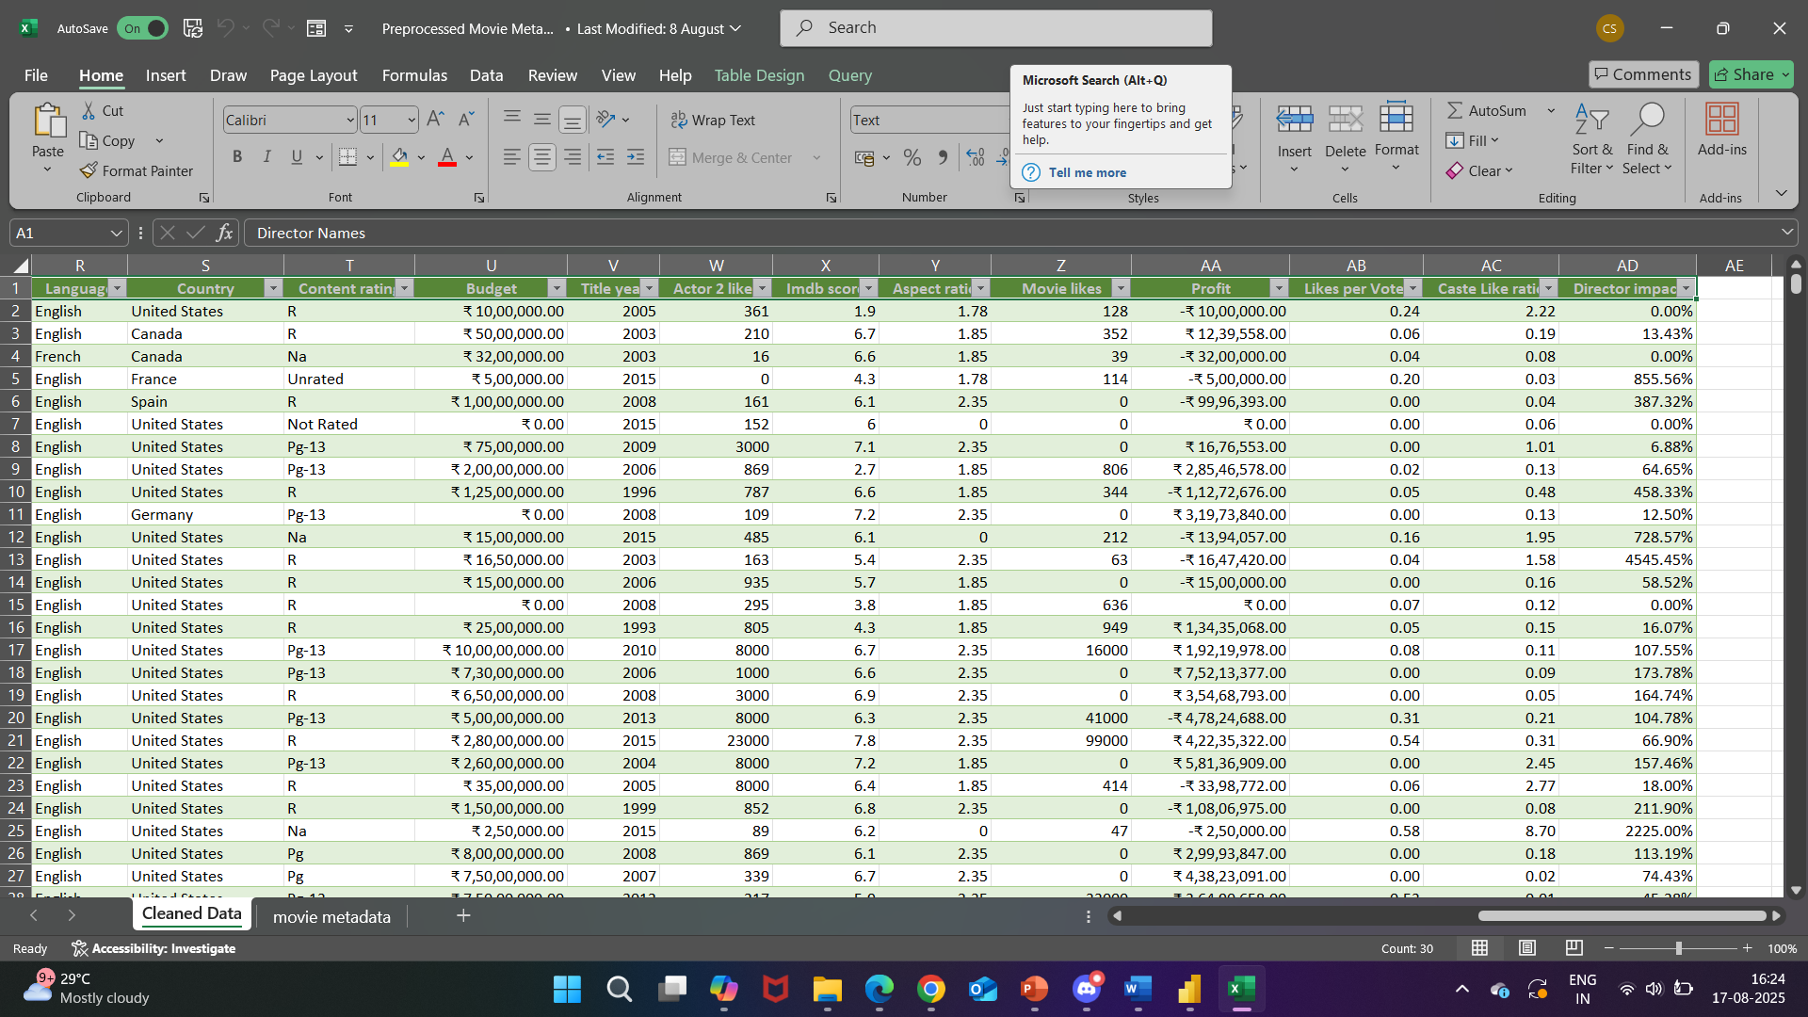

Pre-processed Movie Metadata

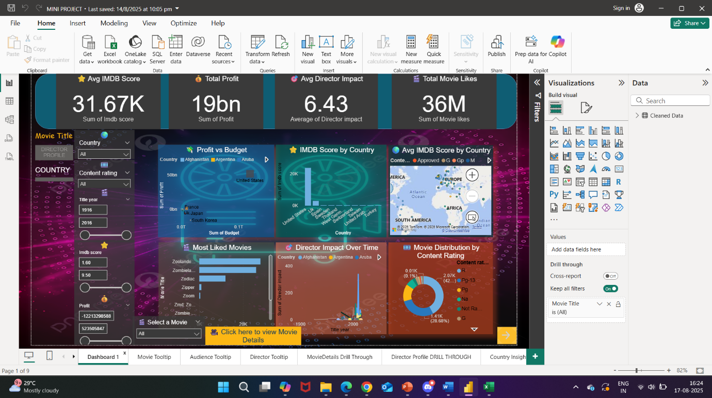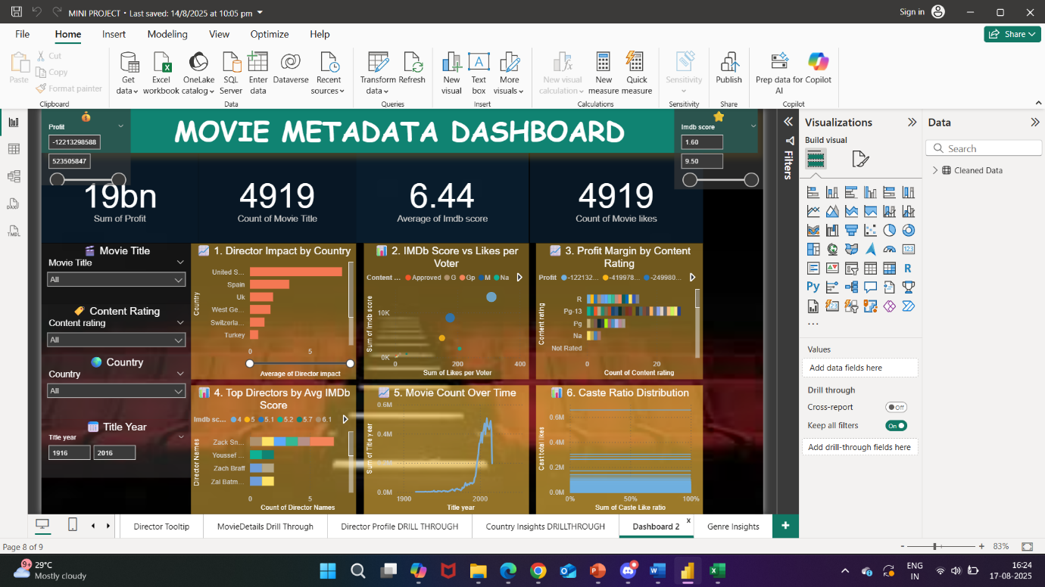

Power BI dashboard

📁 **7. Files Included**

|  |  |
| --- | --- |
| **File Name** | **Description** |
| Pre-processed Movie Metadata. xlsx | Cleaned dataset with basic analysis in Excel |
| MINI PROJECT. pbix | Power BI dashboard with interactive visuals |

🧭 **8. How to Use**

To explore the project:

1. **Open** Pre-processed Movie Metadata. xlsx View the cleaned dataset and preliminary analysis using formulas.
2. **Open** MINI PROJECT. pbix **in Power BI Desktop** Interact with slicers, charts, and KPIs to explore insights across genres, directors, and audience metrics.